[ravularakesh3845891@agentforce.com](mailto:ravularakesh3845891@agentforce.com)

[rakiravula6115@agentforce.com](mailto:rakiravula6115@agentforce.com)

Cloud computing--- without installing any software into local machines by using the internet through the URL, accessing resources and developing the application

Cloud computing will provide

SAAS software as a service

We can use but we cannot modify it

PAAS platform as a service

IAAS infrastructure as a service

SAAS will provide

Sales

Service

Marketing

CRM -Customer Relationship management

When you’re joining a company

The company provides you with the org (Organization)need to develop your code (dev)

Then it should move to the SIT (System integrated testing)

Then it should move to the UAT (User acceptance testing)

Then finally it will be moved to production.

Click Setup and search for creating custom object

Label name--user

Custom Object name---- Salesforce

API name ---Salesforce

Object name always word or word including _.

If labels contain special characters or space, then in object names it will be replaced with underscore _.

If we have special characters and space at the start or ending it won’t be considered.

When you are creating the object by default one column(filed) is created automatically.

API name is also automatically created which will be given by user (Username) by default.

It is like a unique identity

C means custom

API--Application Programming Interface

When you are creating objects by default 4 fields are created standard by salesforce.

if you name your custom object with spaces in the **Label**, like:

* **Label Name**: Hospital Name

Salesforce automatically generates internal names like this:

| **Type** | **Value** | **Notes** |
| --- | --- | --- |
| **Label Name** | Hospital Name | Friendly name shown in UI. |
| **Plural Label** | Hospital Names | For tabs/list views. |
| **Object Name** | Hospital_Name | Internal API-style name with underscore. |
| **API Name** | Hospital_Name__c | Used in code (must end in __c for custom objects). |

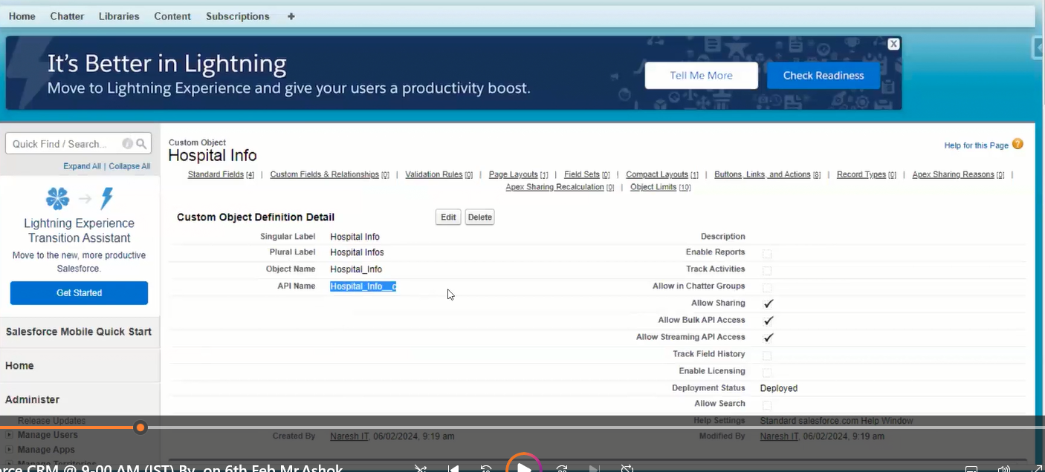

Now the object is ready we need to create tab

Click Setup and search for creating custom tabs

Storage space is ready need a tab to enter the details from the end user.

The plural label name in custom object comes as a tab name

When you are changing the plural name the tab name is automatically changing

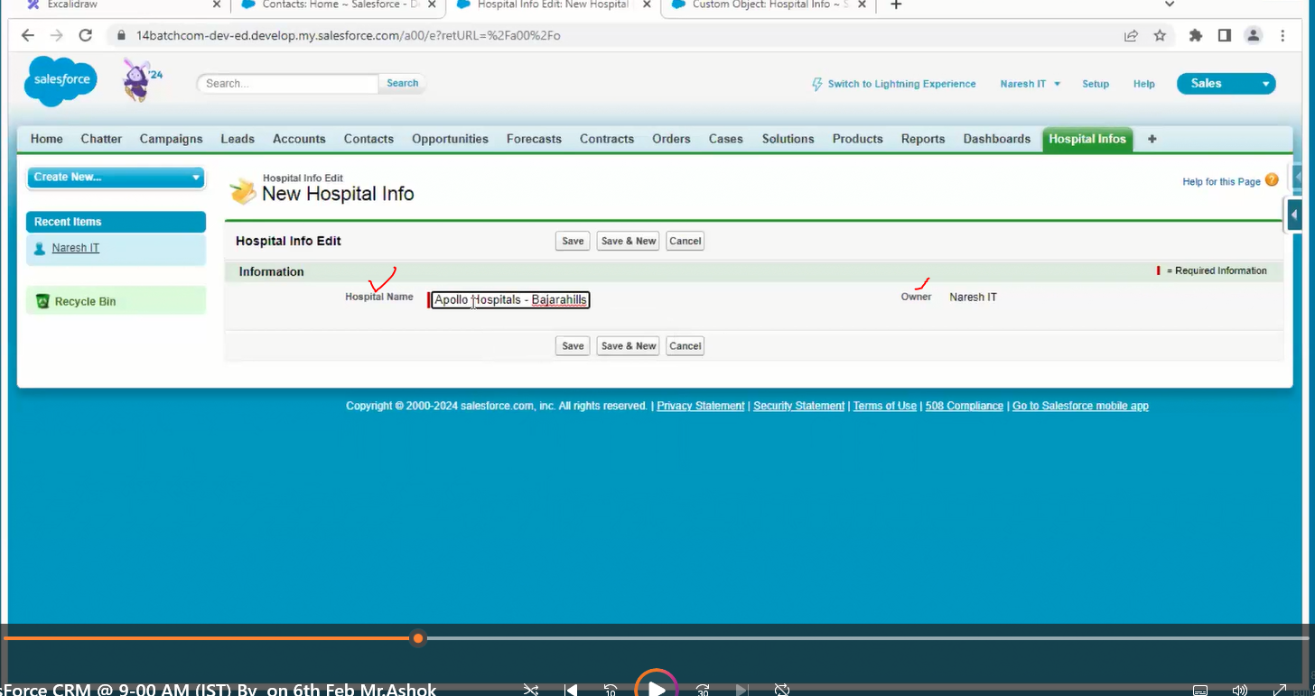

In the above we have 2 fields, one is hospital name, and owner is automatically filled by the system

For every record owner must be there.

Pick list

Number

Currency

Text

| **Field Type** | **Description** | **Analog in Programming** |
| --- | --- | --- |
| **Text** | Stores alphanumeric strings | String |
| **Number** | Stores whole or decimal numbers | int, float, double |
| **Currency** | Stores numeric values with currency format | float with formatting |
| **Picklist** | User selects from a dropdown list of options | enum or String[] |
| **Checkbox** | Boolean true/false value | boolean |
| **Date** | Stores only the date | Date |
| **Date/Time** | Stores date and time | DateTime, timestamp |
| **Text Area** | Multi-line text | String (multi-line) |
| **Lookup** | Links to another record | Reference or foreign key |
| **Auto Number** | Auto-generated number (like an ID) | Auto-incrementing int |
| **Formula** | Automatically calculated field based on logic or math | Function, Computed Field |

Ok now we have hospital information, doctor, patient & bed tabs

Please add all those tabs in one app, so create a new custom app

Click Setup and search for creating Apps

To add the icon to the app we need a document folder to store an image

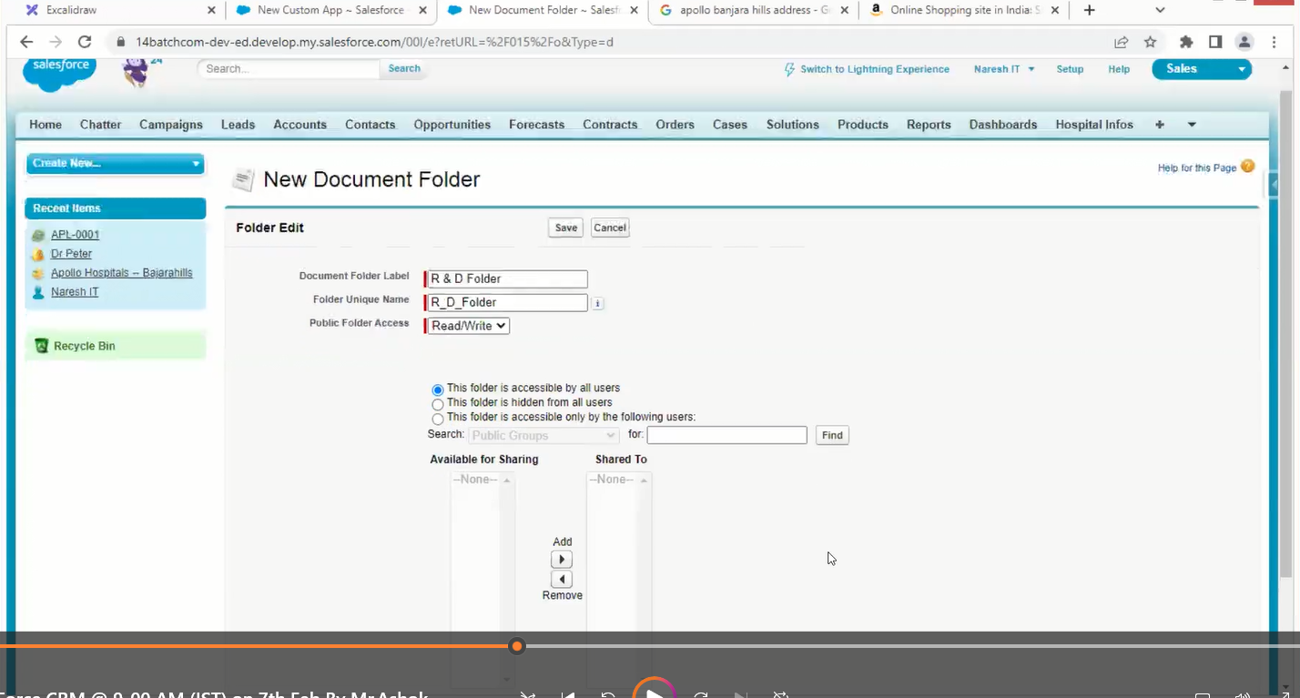

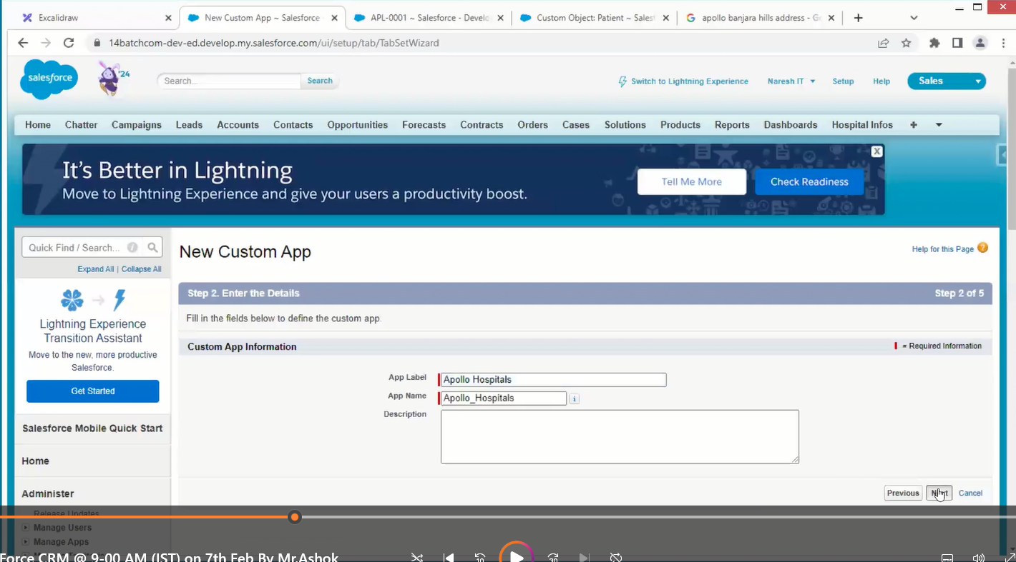

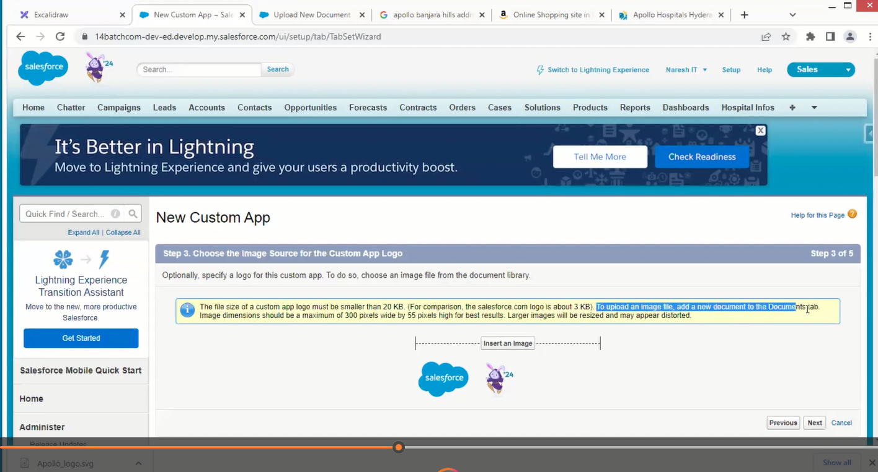



Every App have multiple Tabs

Every Tab has one object

Objects have multiple fields.

If data is increased the performance of the app decreases

In general, we will compress the data to zip file of lesser mb

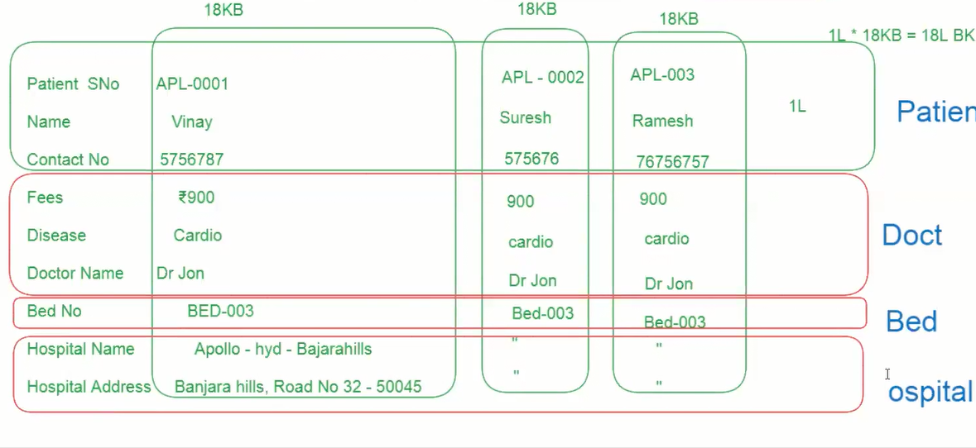

Data redundancy means duplicate data

The connection between the 2 objects is called a relationship

to reduce data redundancy.

Relationship into 2

1. Optional Relationship
2. Required / mandatory Relationship

Option relationship is nothing, but the object may require or not for relationship.

Required or mandatory means this object is 100 percent required for relationship.

1. Optional Relationship
2. Lookup relationships
3. Required / mandatory relationships
4. Master detail relationship

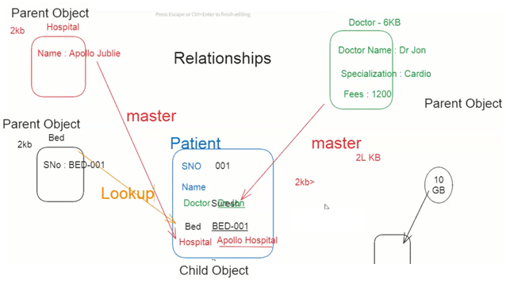

To create a relationship between objects, go to the child object and go to the new field /relationship

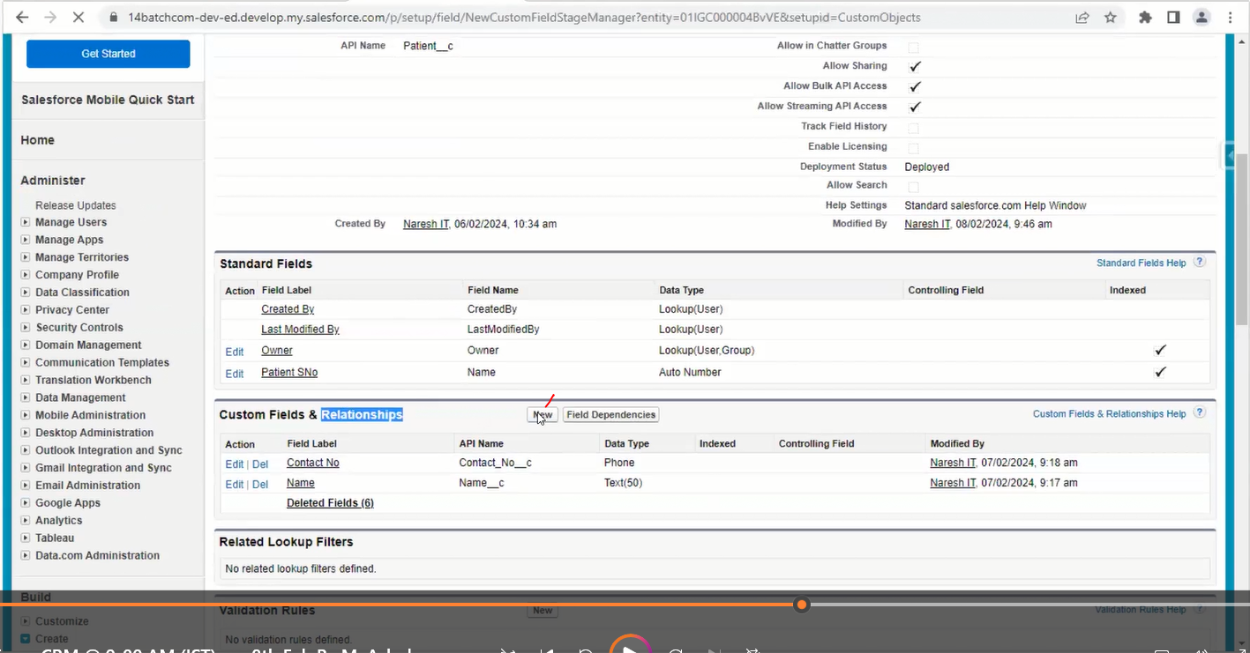



Case 1

Remove all the records of child-record and create (not recommended)

Case 2

Create LoopUp and update all relationship fields then convert it to master

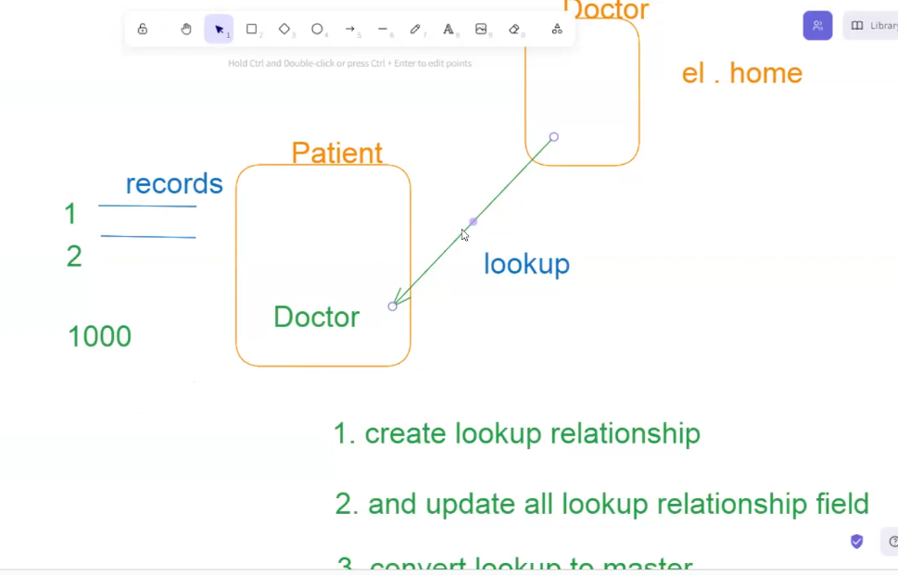

In this case if a patient object is having 1lakhs record to update this it will take a lot of time for this we have some tools which are not created by salesforce

Data loader

Import wizard

Work bench

Inspector

Per object we can create only 2 master relationships and 40 lookup relationships

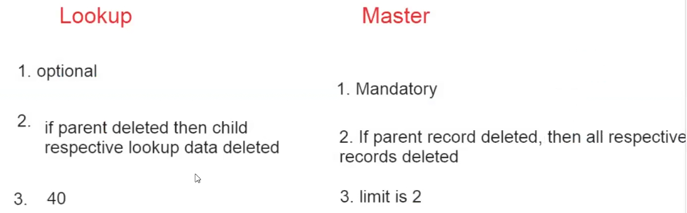

Sales force is going to provide editor to return some logic

After writing the logic in the editor when we submit it will go to complier to going validate our logic and then it moves to runtime engine giving the out put

Age is formulae we need to create formulae filed first

Formula fields

go to the object and go to the new field /relationship

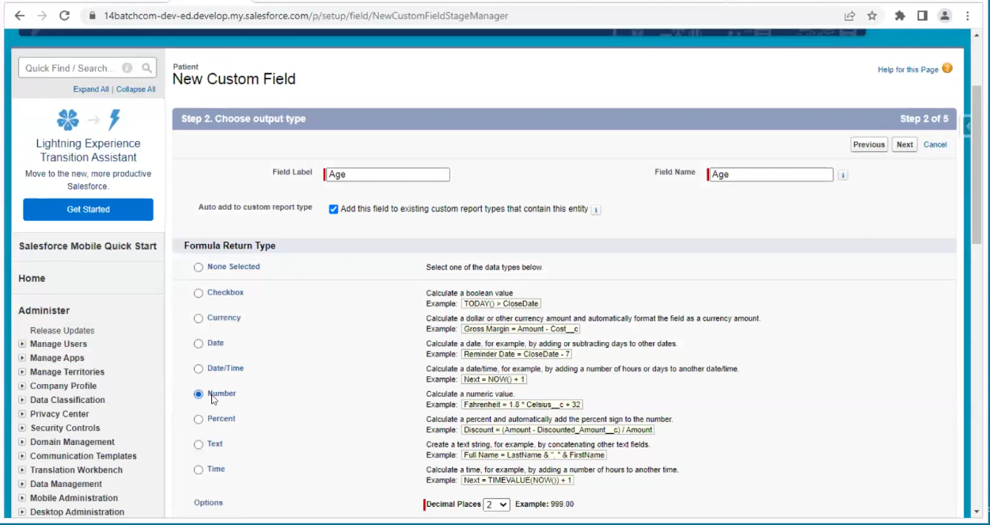

Display purpose labels names come as tab names

Logic purpose API names

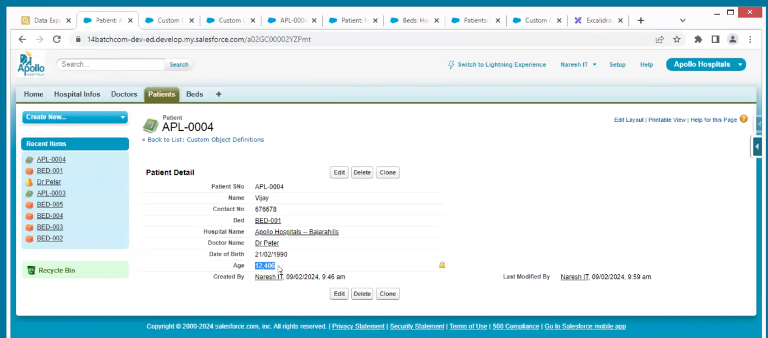

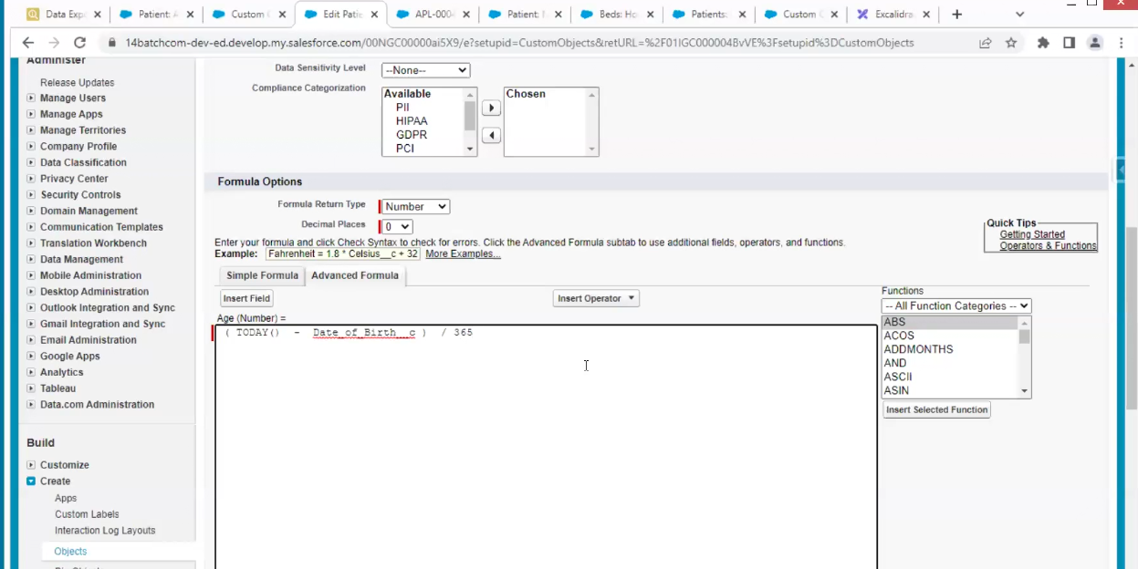

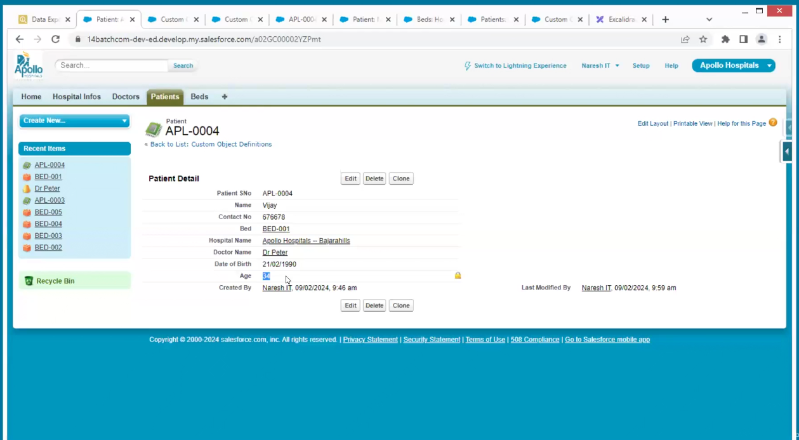

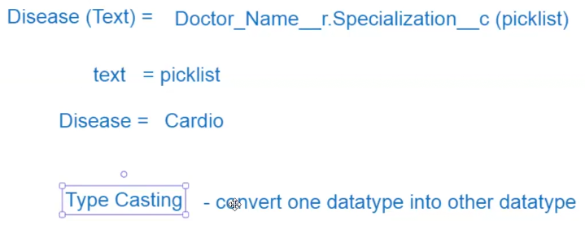

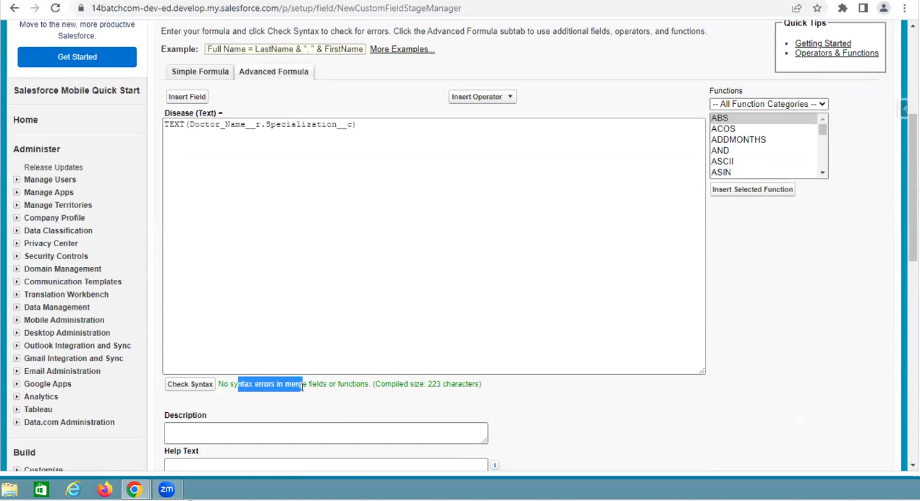

By using formulae fields, we can call the fields from doctor which of master detail relationship.

Formulae fields are used to automate the processes.

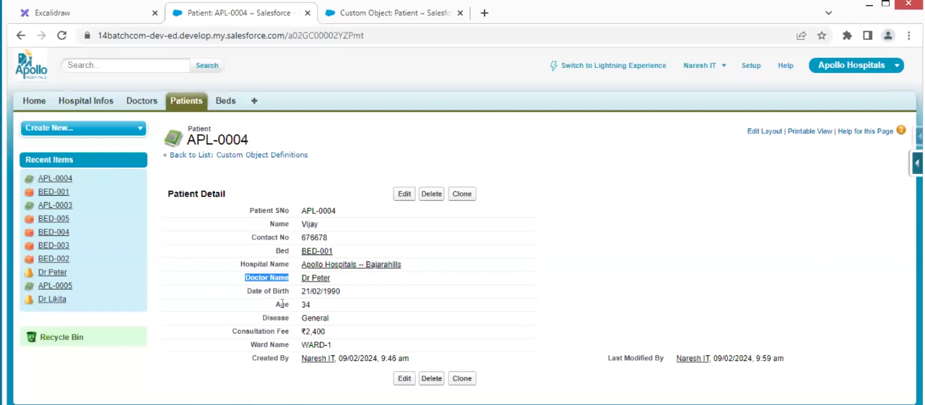

Page layout

We can create multiple sections

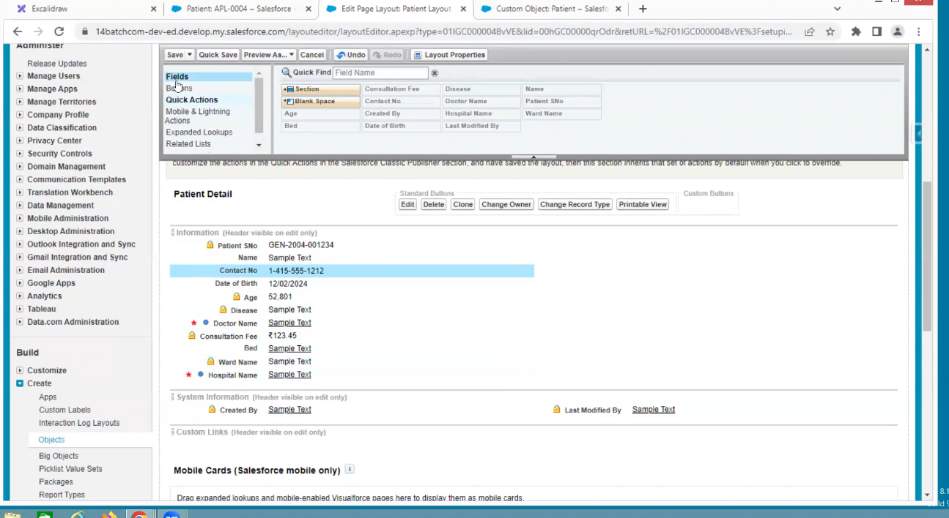

In above I don’t require delete button then hide it

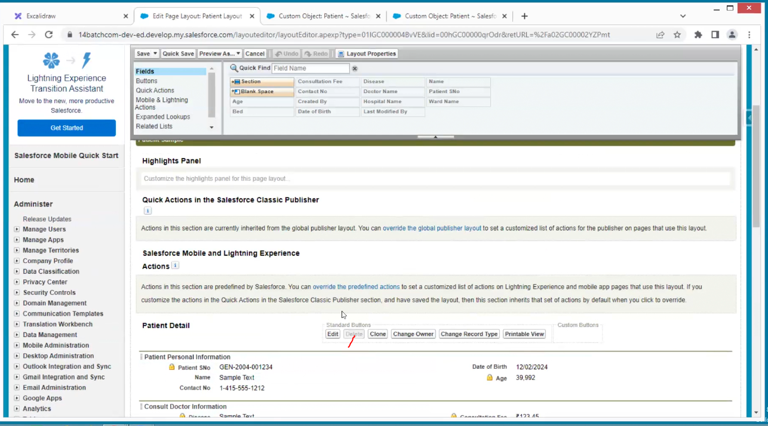

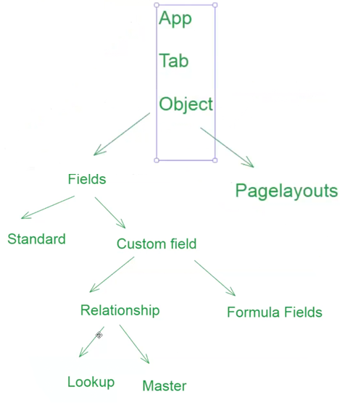

Create the bar code

For example, in bar code we are putting mobile number

By formulae fields

To barcode generation, take any help of google barcode generator API

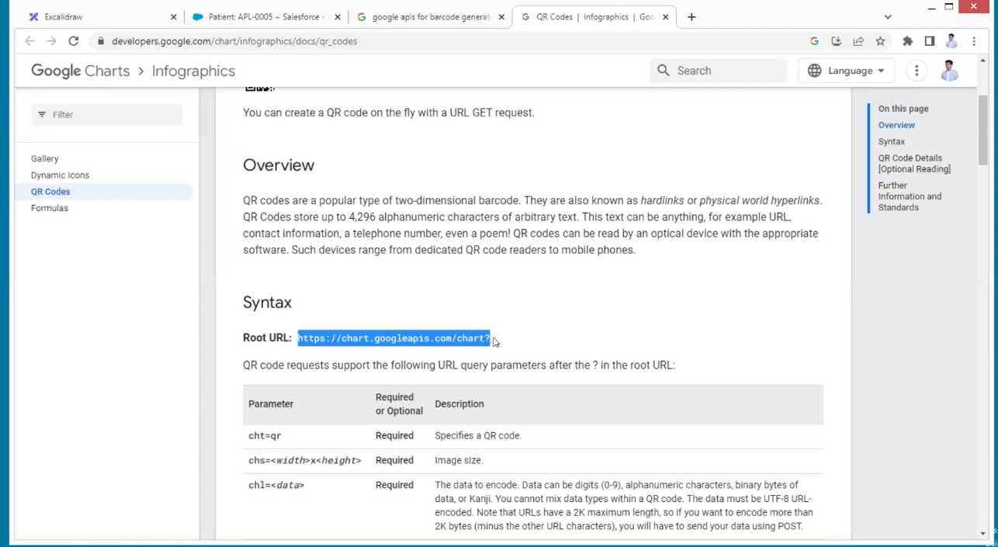

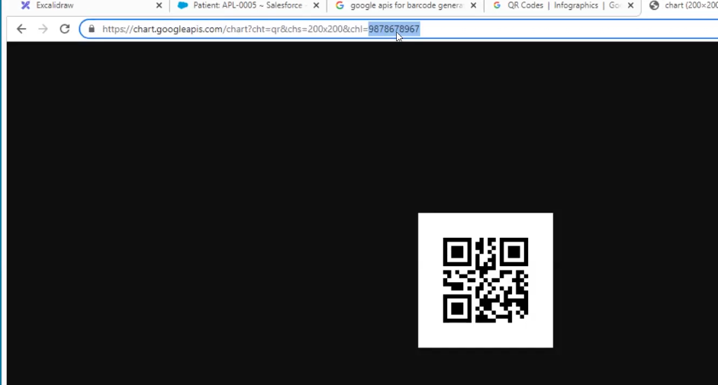

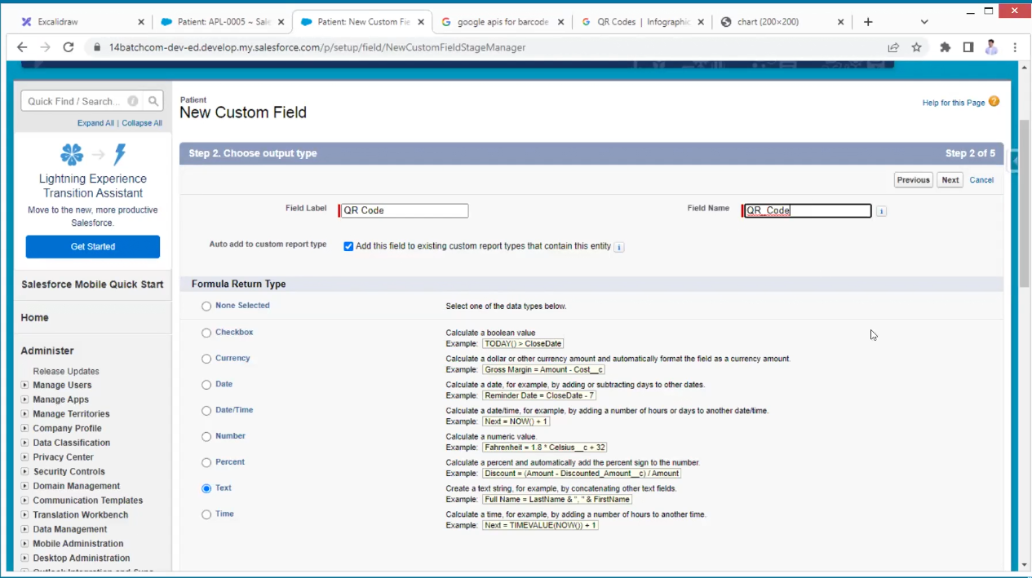

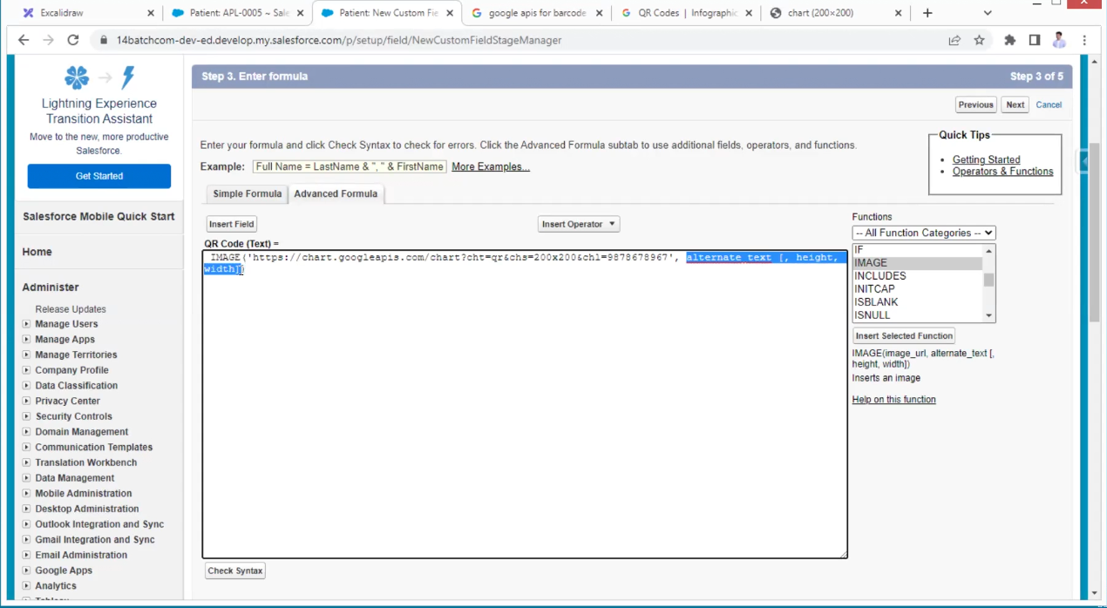

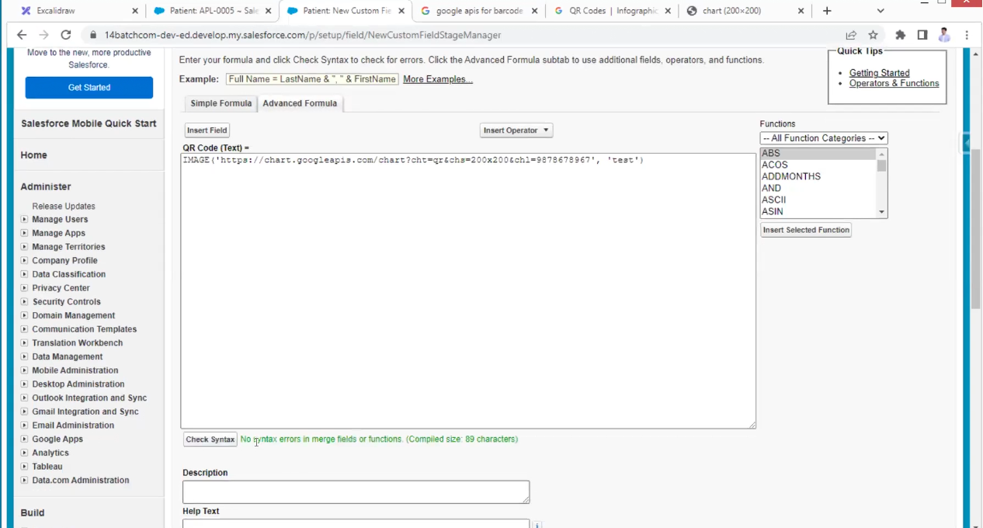

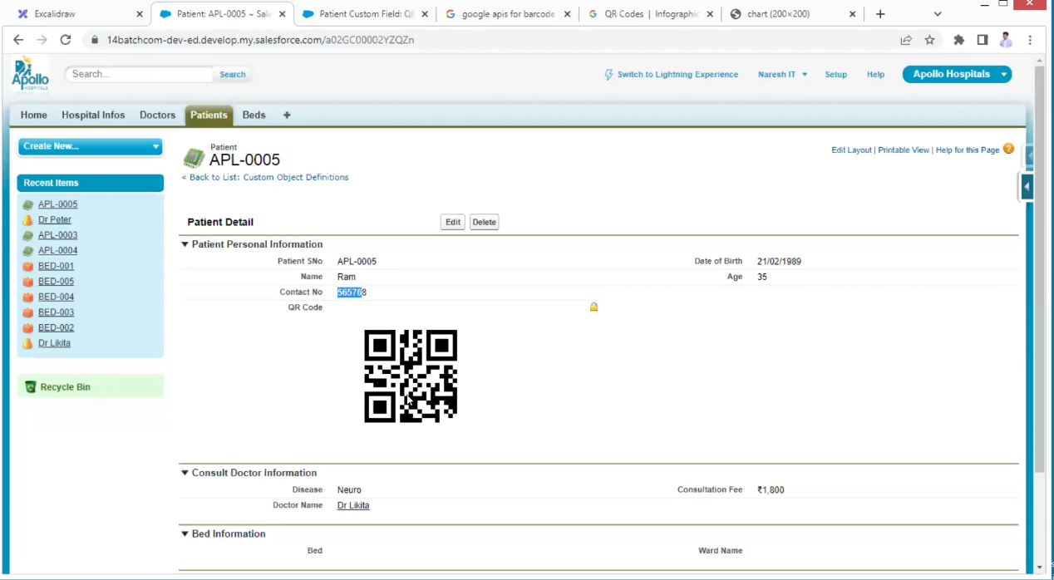

In this case we are getting only static data of single number if change number if scan we are getting old number

We need dynamic data

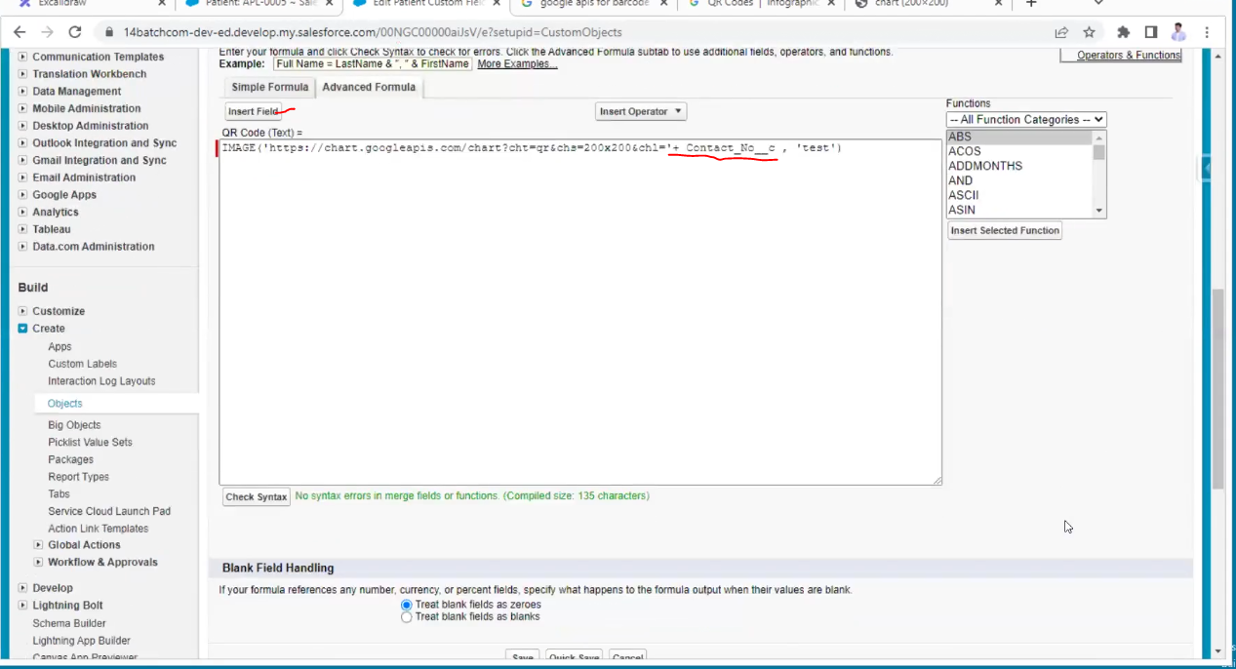

One-to-one relation (one patient, one doctor)

One to many (one doctor many patients)

Many to many (one hospital many patients, one doctor many patients mean hospital is indirectly connected to doctors. Patient point of view doctor is mandatory relationship and hospital also mandatory relationship)

In the above case, a patient object is a junction object which can hold two master relationships or two parents

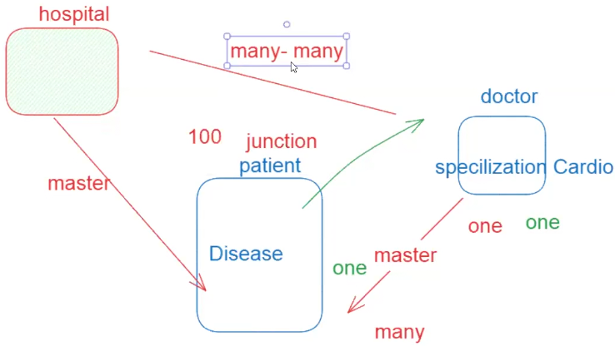

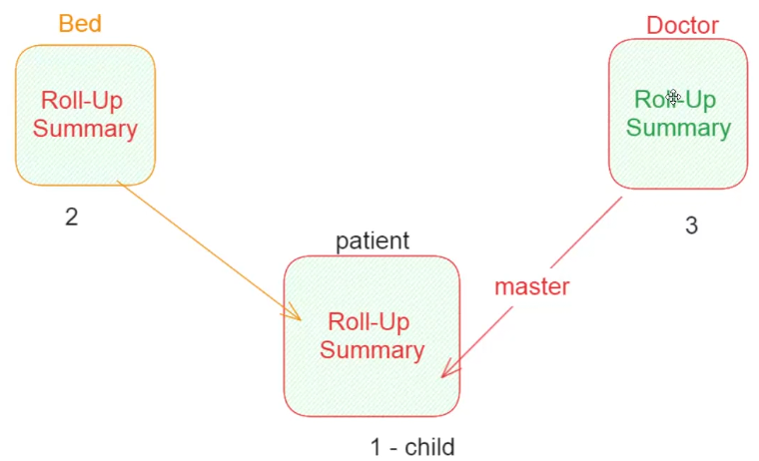

Go to master detail relationship object

That is doctor in that go to new fields then select roll-up summary

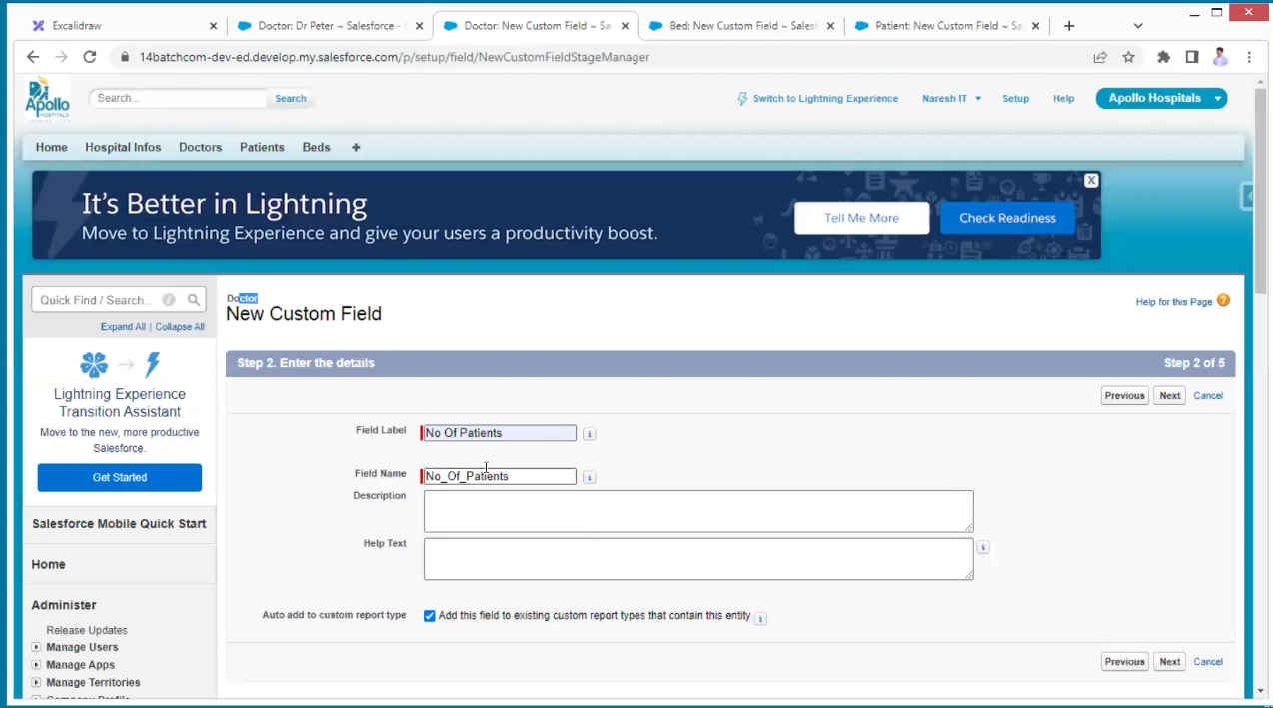

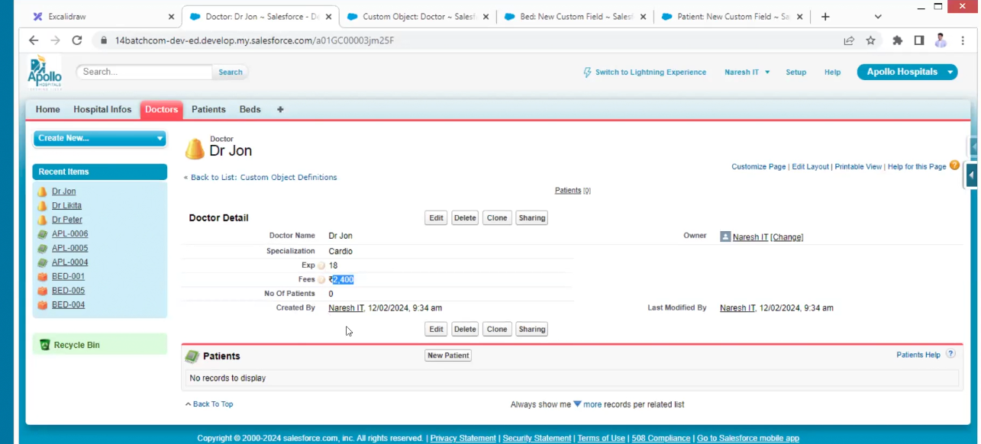

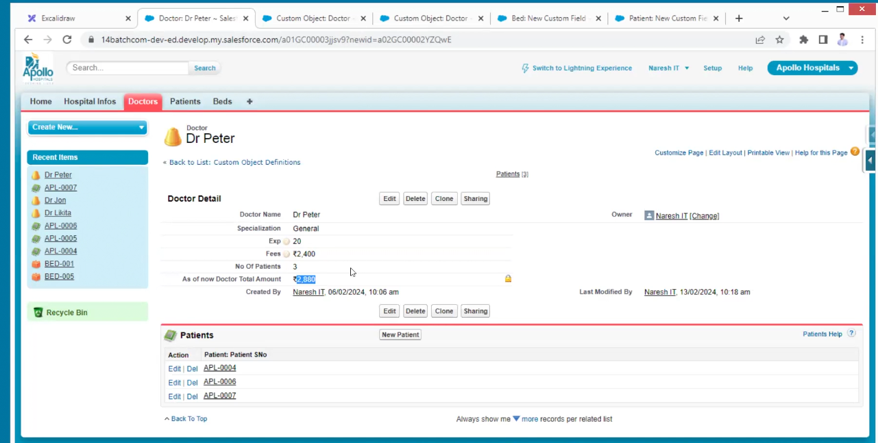

Doctor is taking 40% of fee

Remove button

Roll-up summary does not work for formulae fields

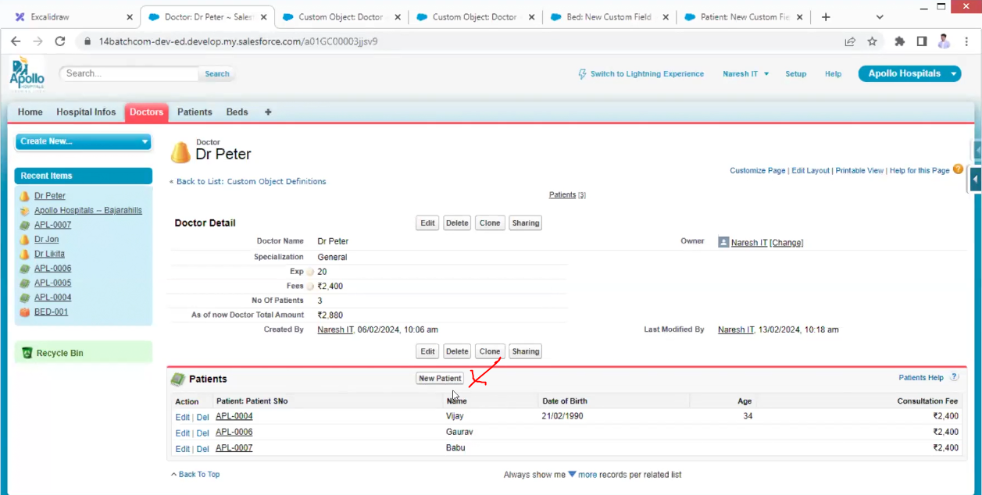

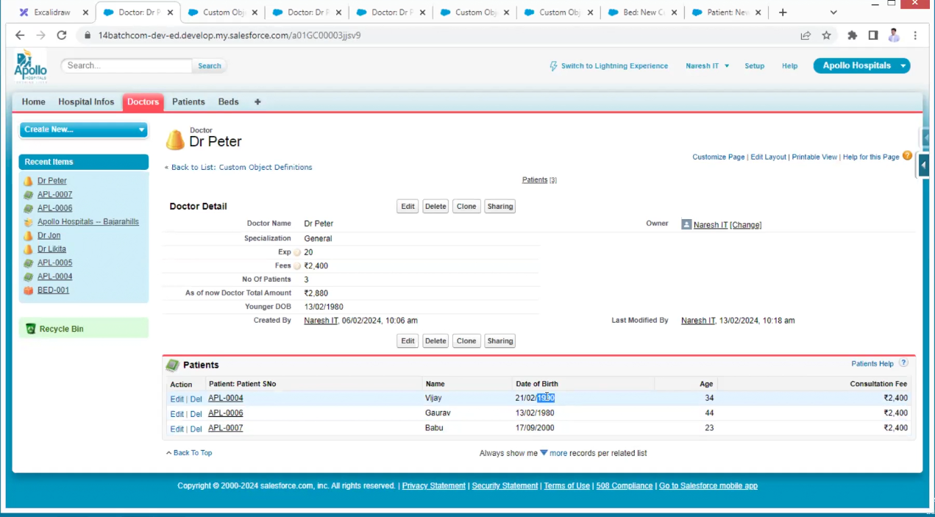

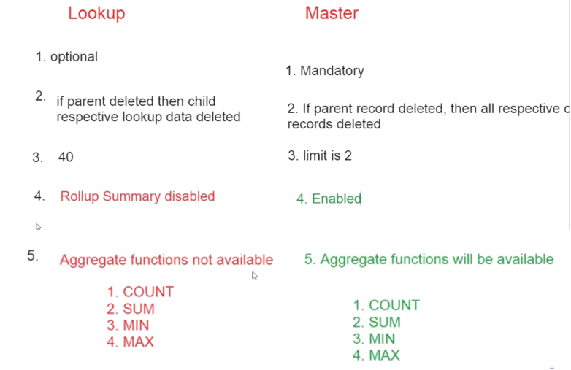

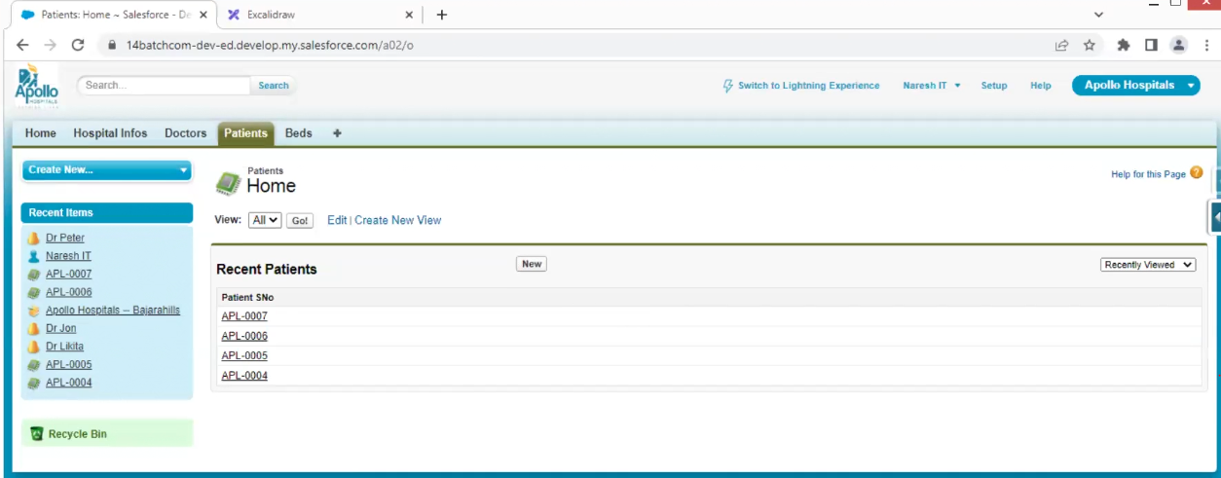

The above is the patient list view.

I need to see the other details here.

Click on the edit button from above

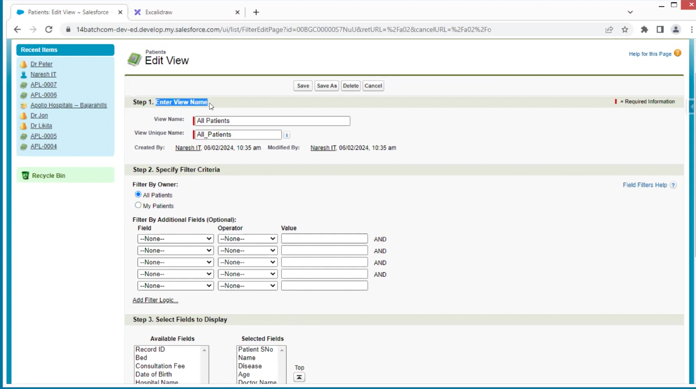

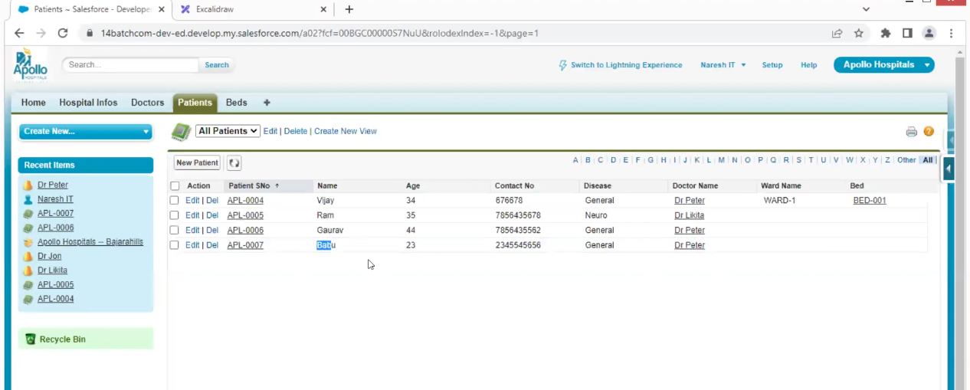

For doctors also make the same

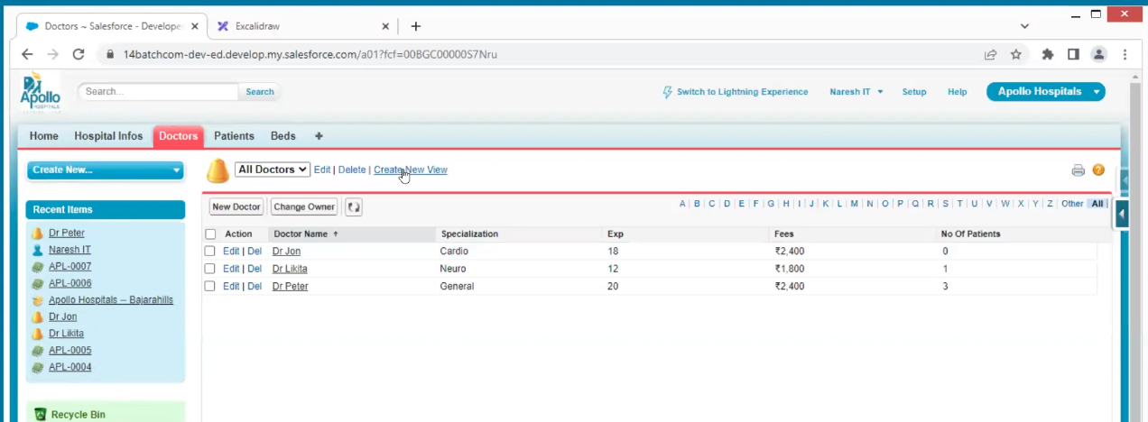

The above is one list view and now a need different list view as neuro, cardio separate

Then we need to create new views

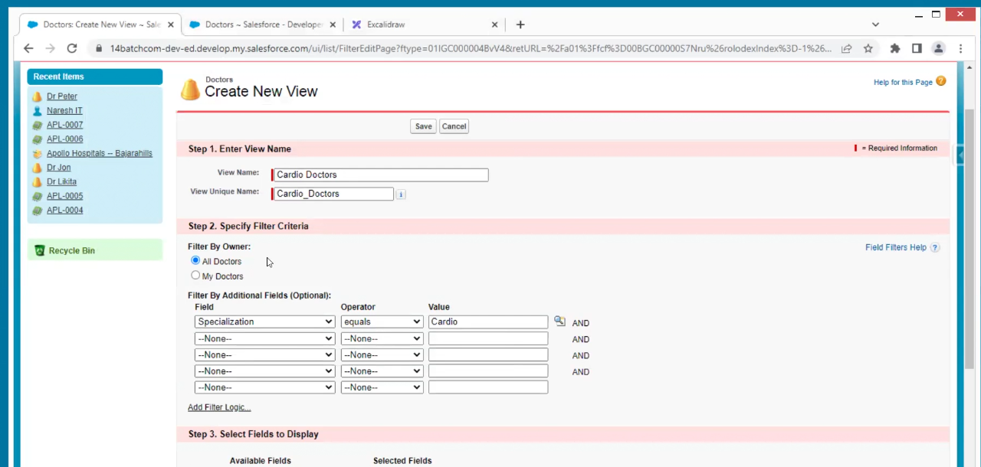

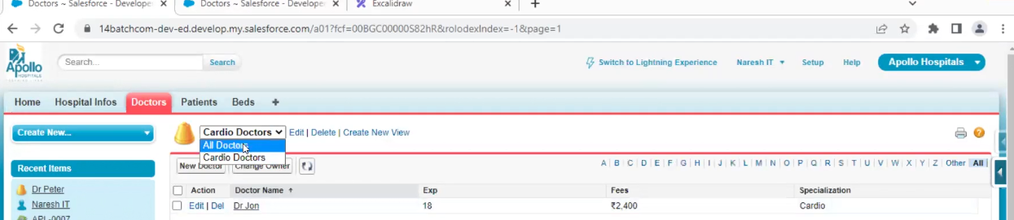

Now we have 2 list views all doctors, cardio doctors

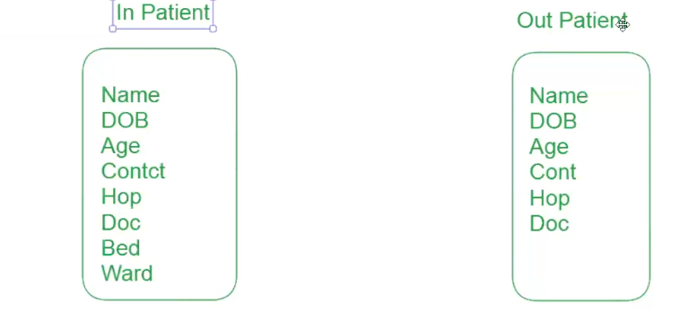

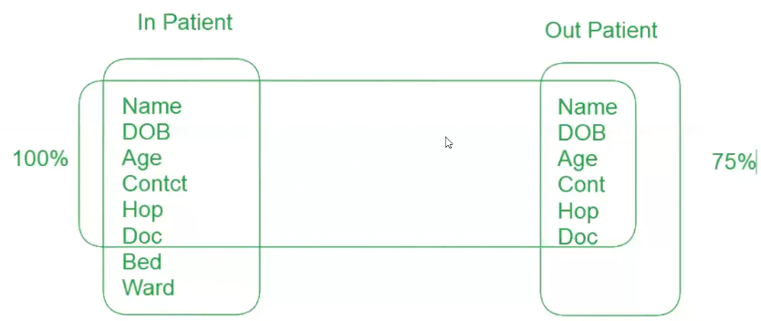

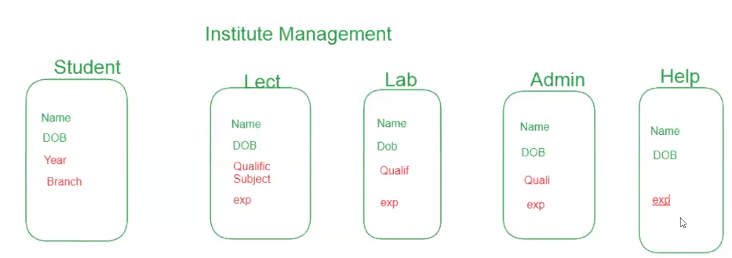

If we create each object from above, we need to create 5 objects having some same data and duplicate data are present and we have only 2 master relation for object, so this is not recommended

Page layout means set of fields and actions

Record types

To avoid that we need to put all the data in one object and we can create 5 different page layout ,but when you are clicking new it is going to always default page

To avoid that we have record types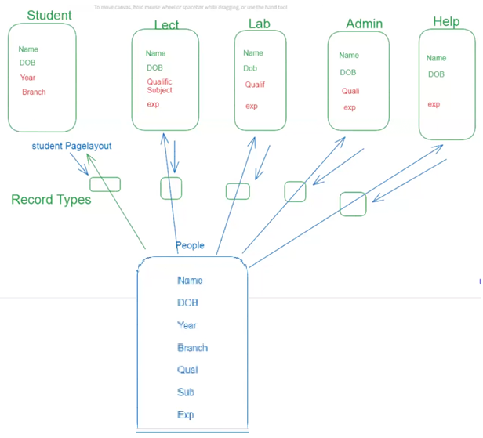

Record types tell us which page you want to open.

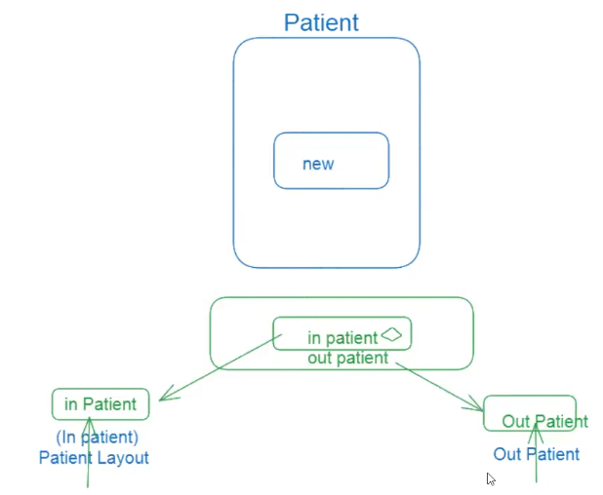

We are creating new pages layouts inpatient and outpatient

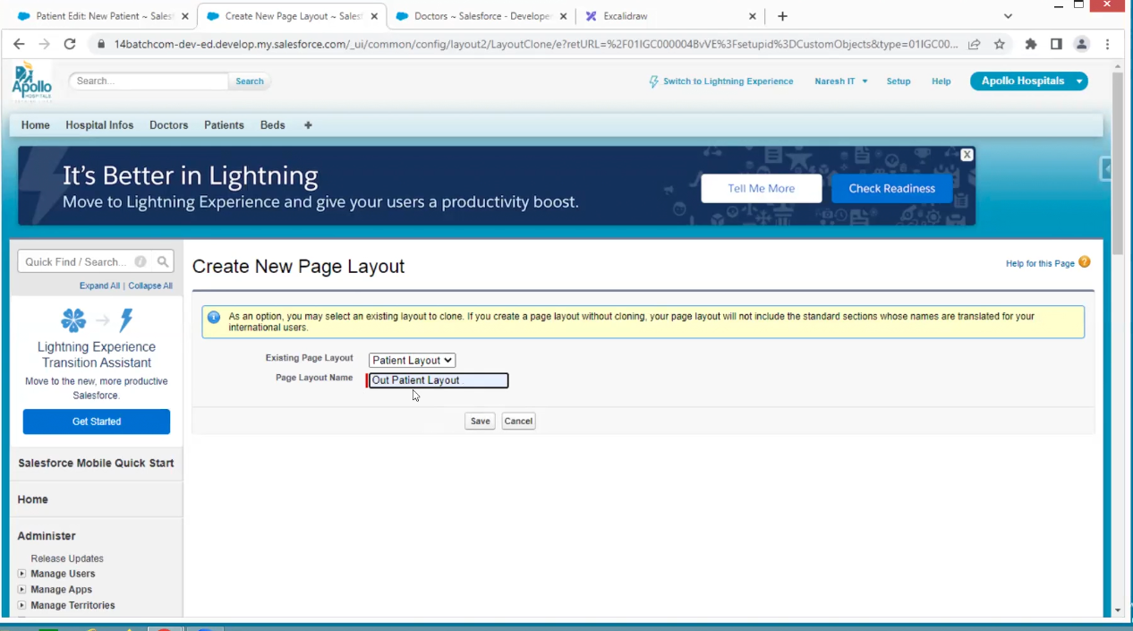

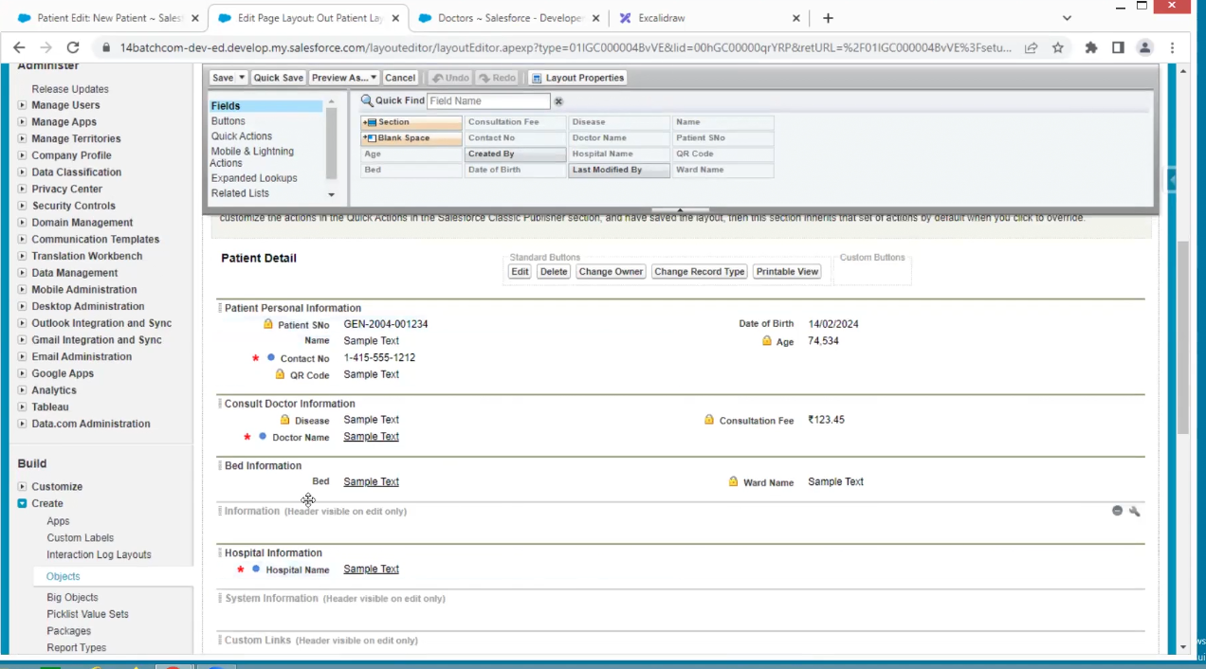

For outpatient bed is not required then remove it

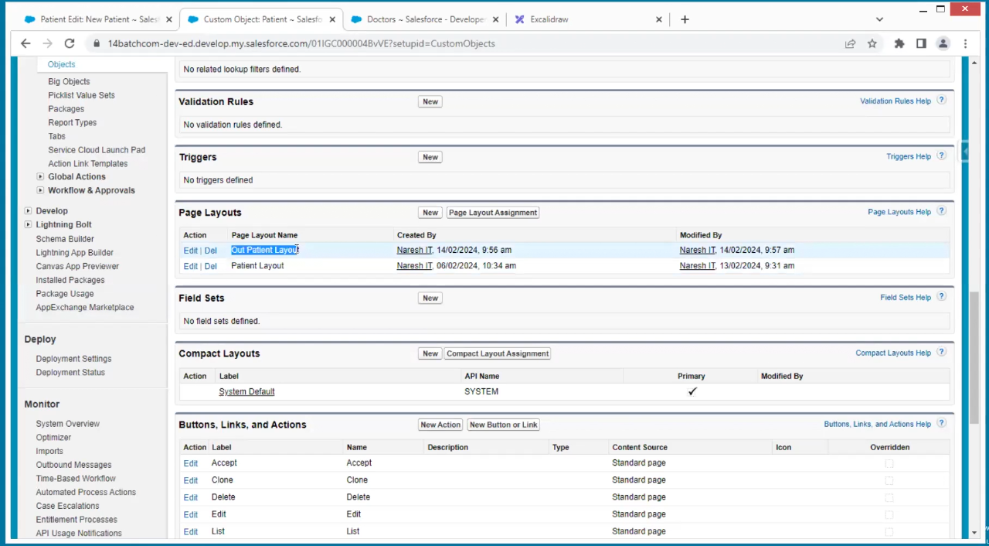

We have a two-page layout if we click on new in record it always takes to default record so to avoid that we need to set record type

In patient object we have record types the click on new

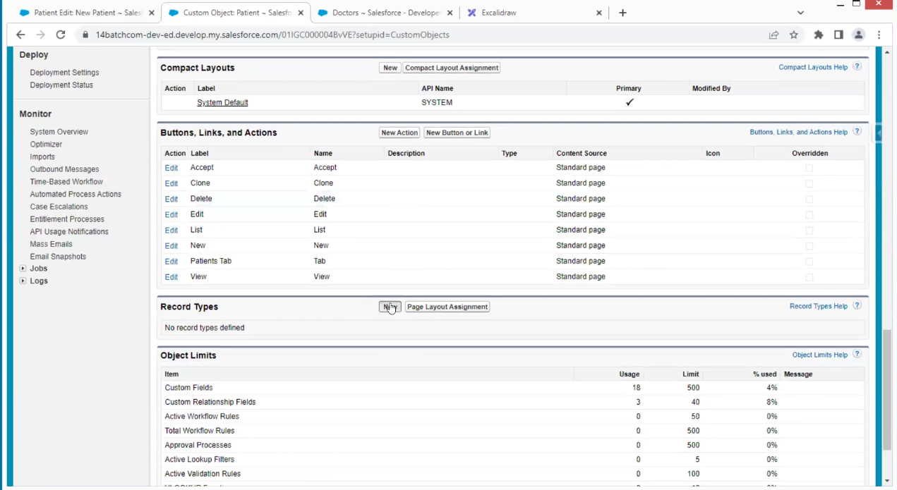

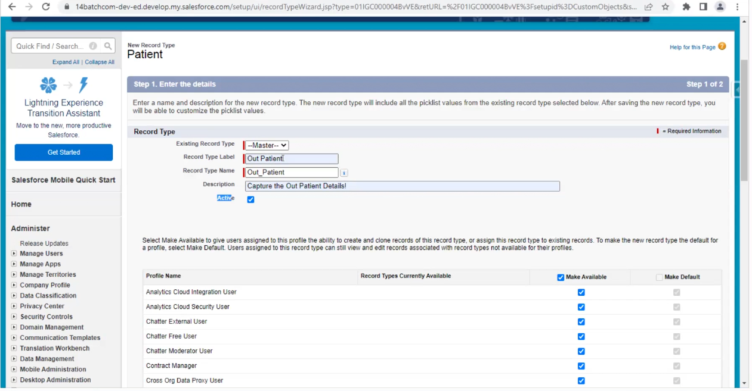

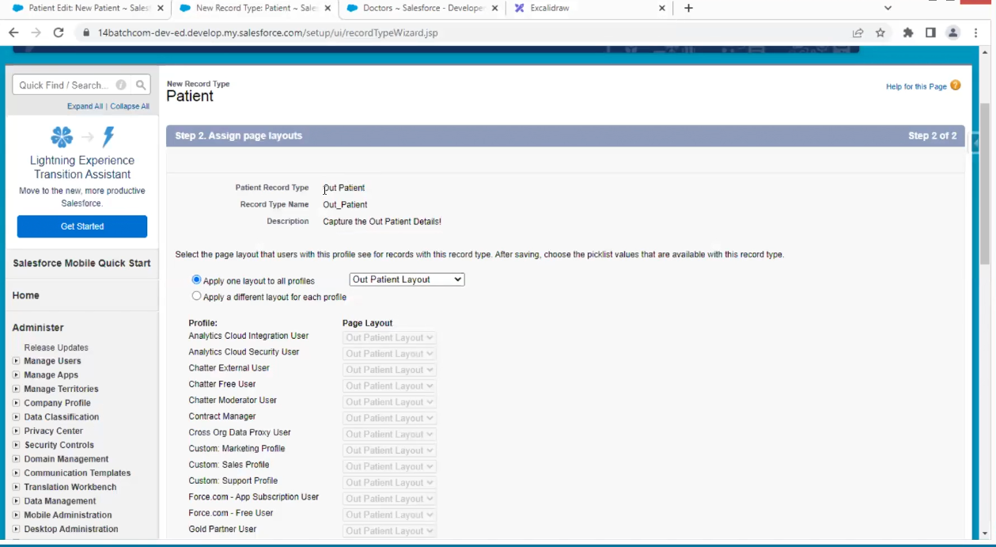



Create the record type to inpatient also

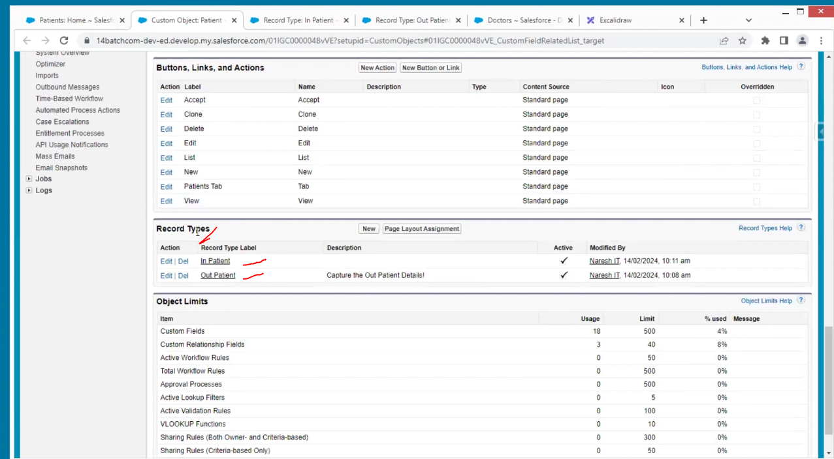

If we select new in patient, we have two record types

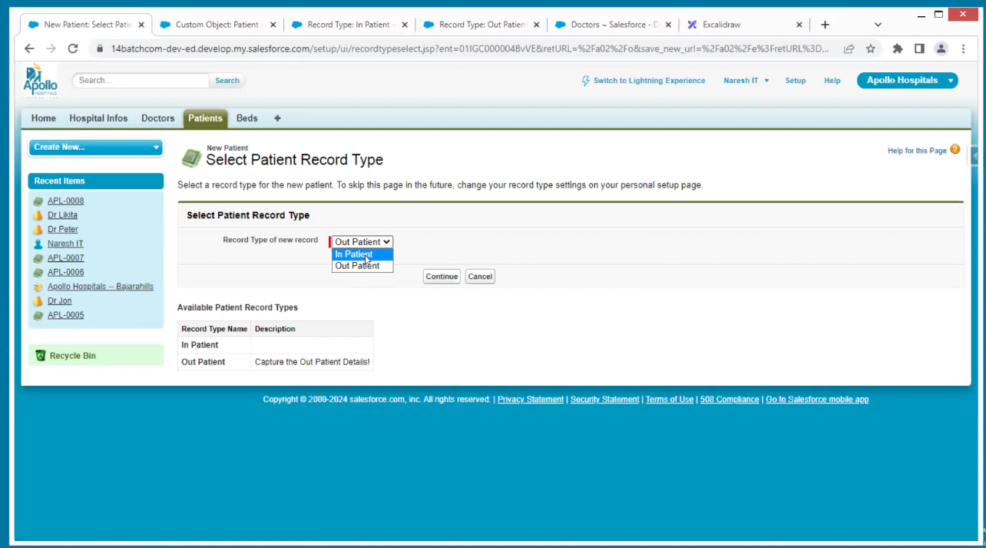

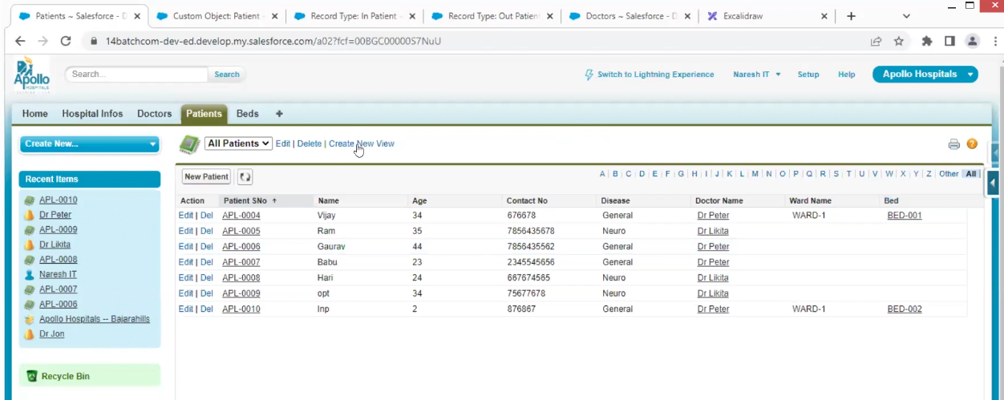

Now I need to see inpatients and outpatients separately go to create new views.

Edit is to display entire data as above

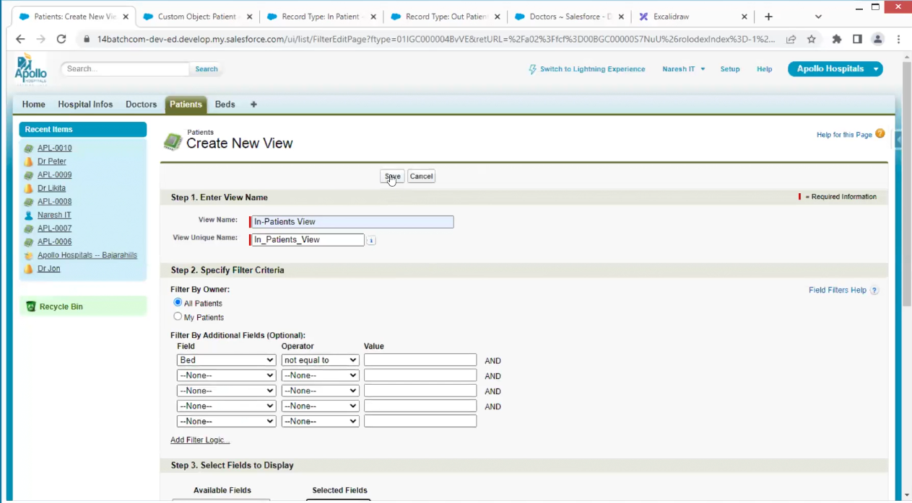

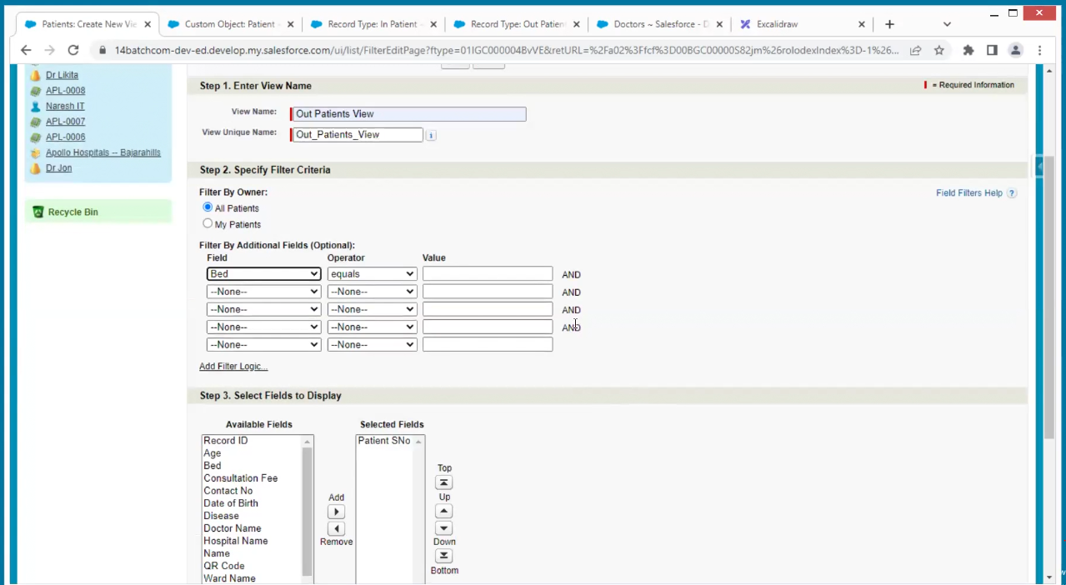

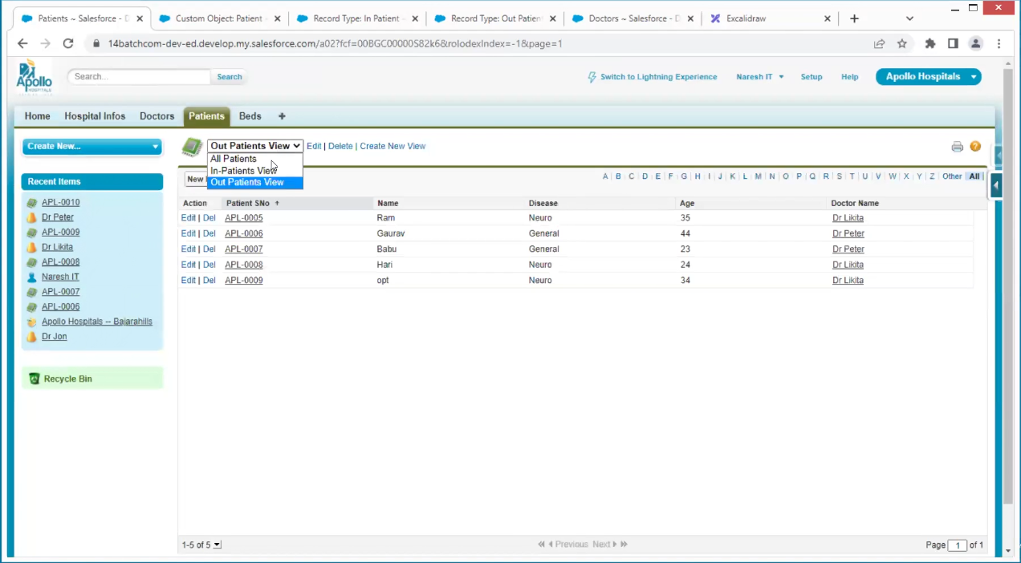

For example, in patients I am not filling the bed, and I can save it this should not happen

For Inpatient the bed is mandatory

Making mandatory in filed level but problem

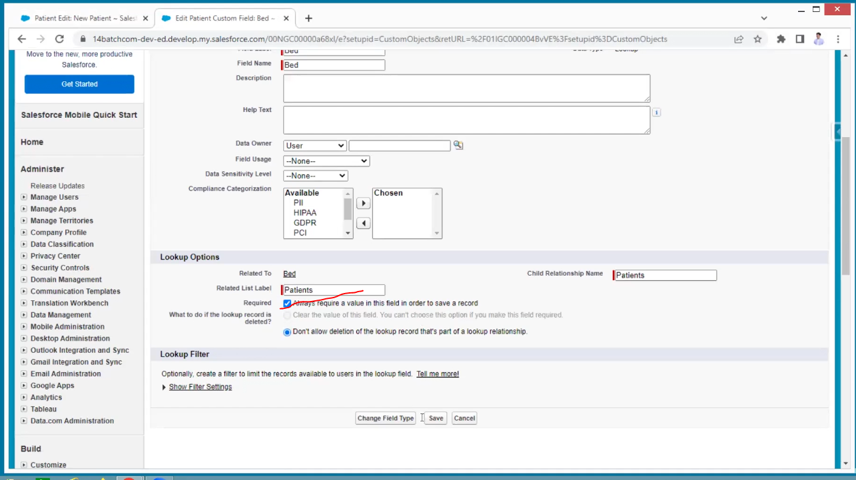

But in the outpatient also bed is displaying this is not suitable in this case

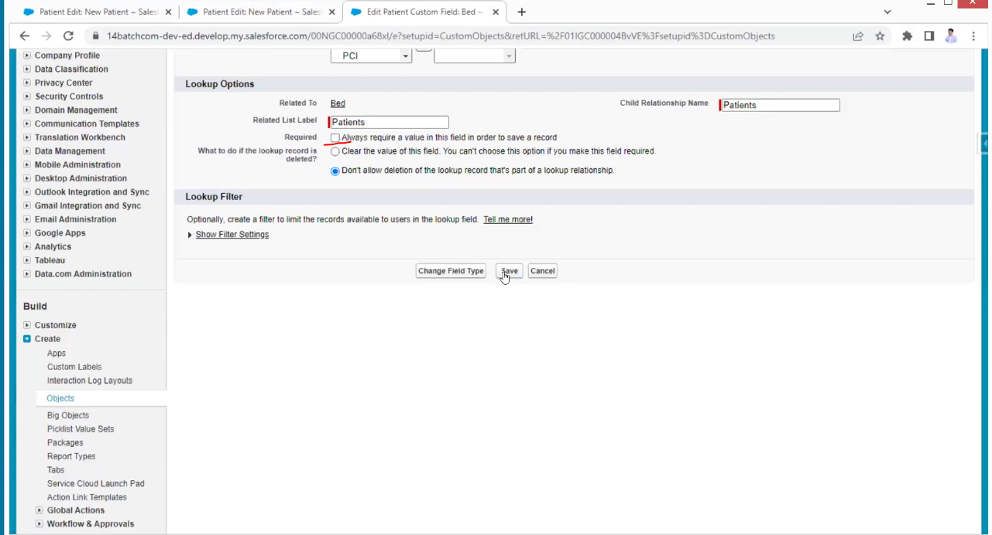

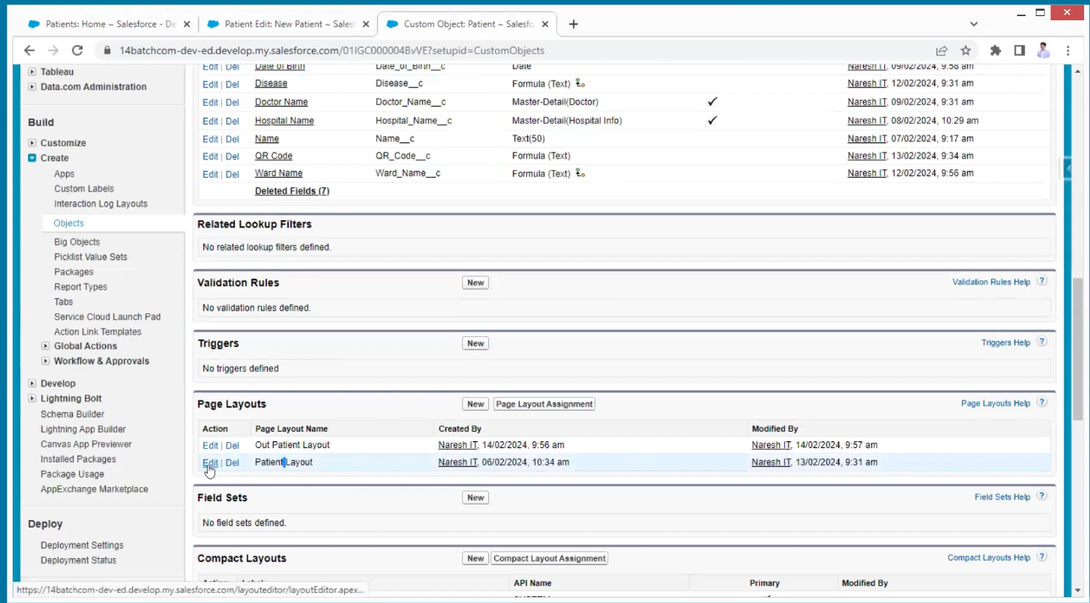

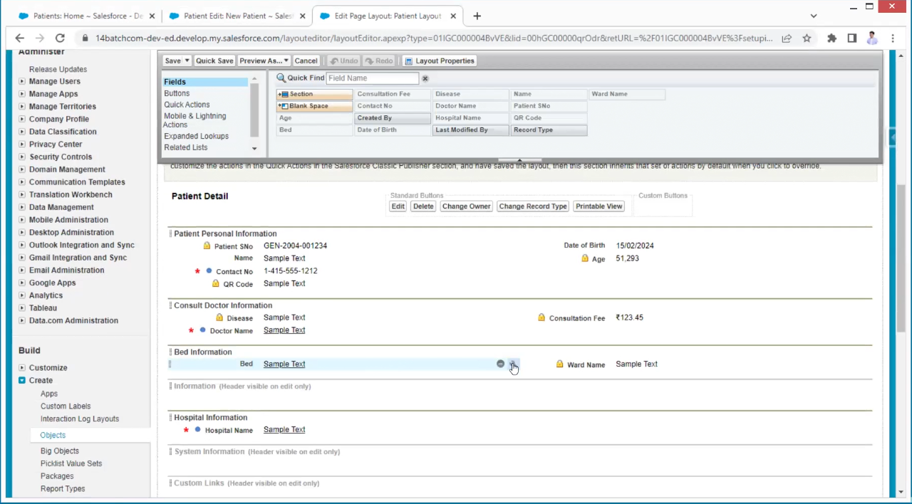

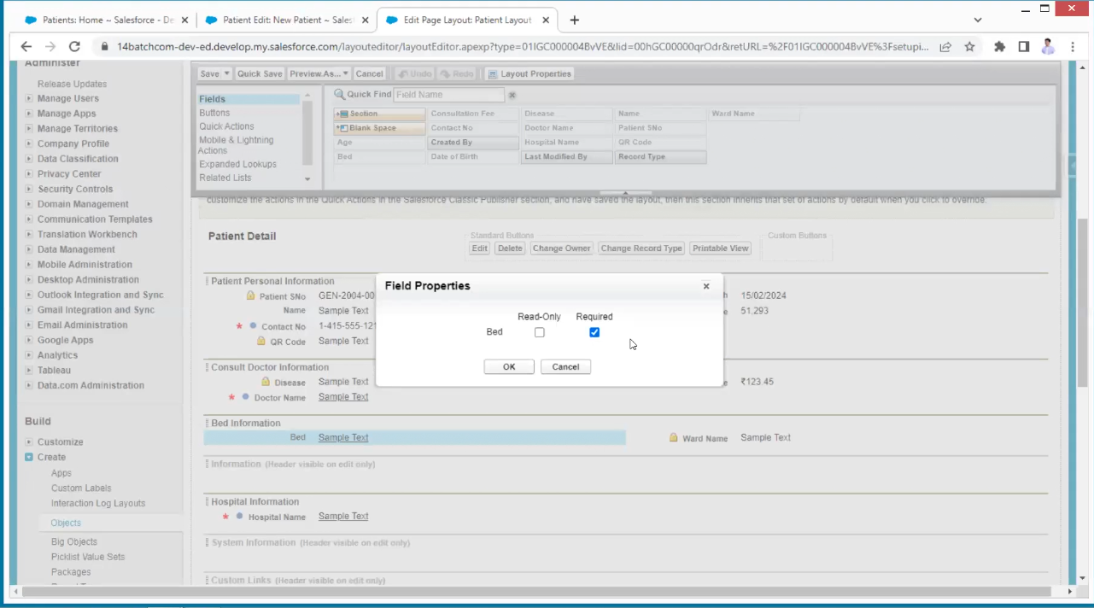

This is the page level record mandatory

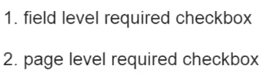

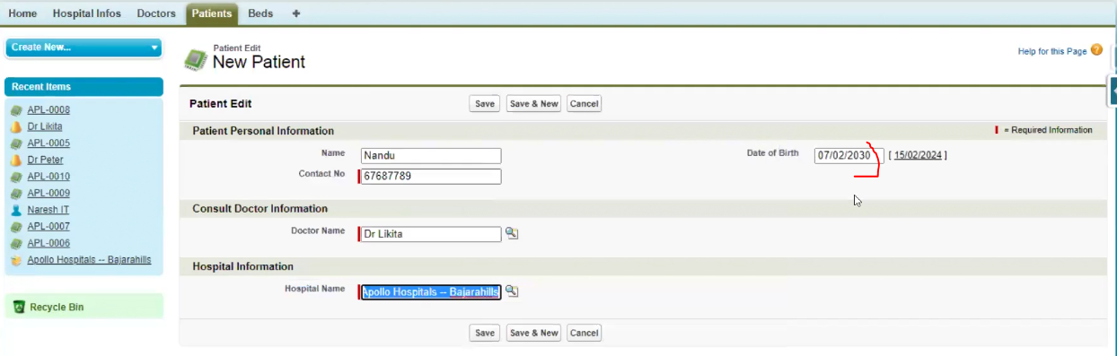

The date of birth must be today or less than today.

This is like to validate the data the concept is validation rules

in custom object of patient’s details go to validation rules

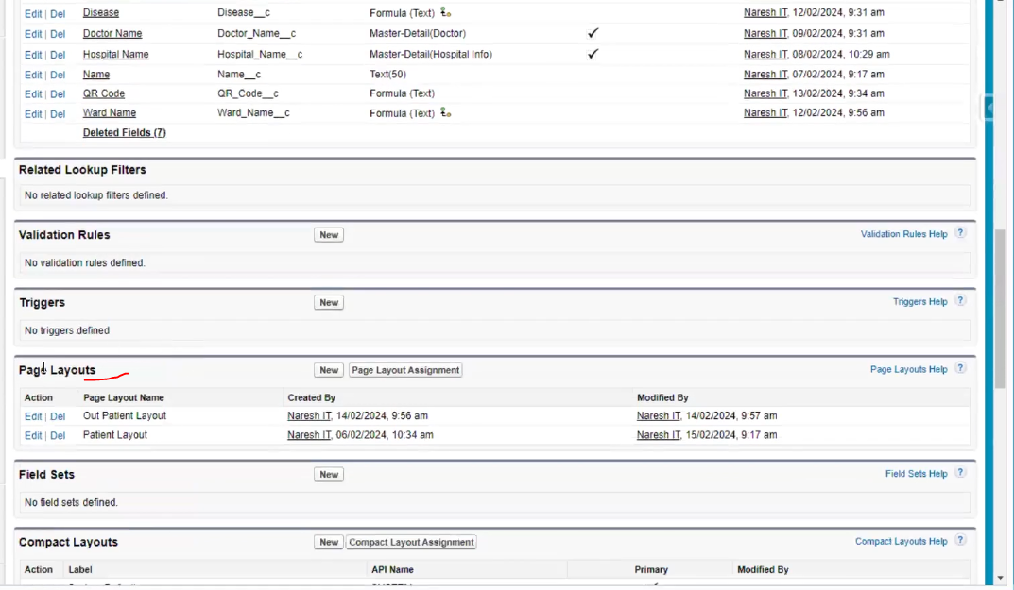

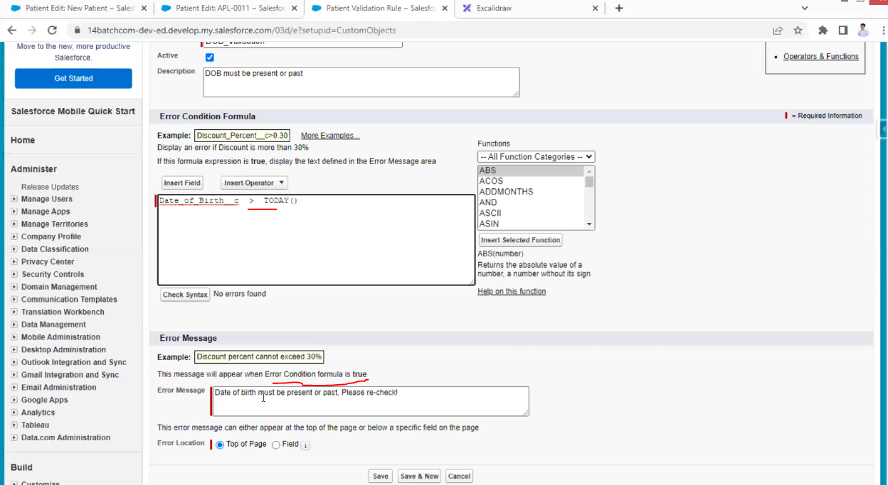

Another example from bank

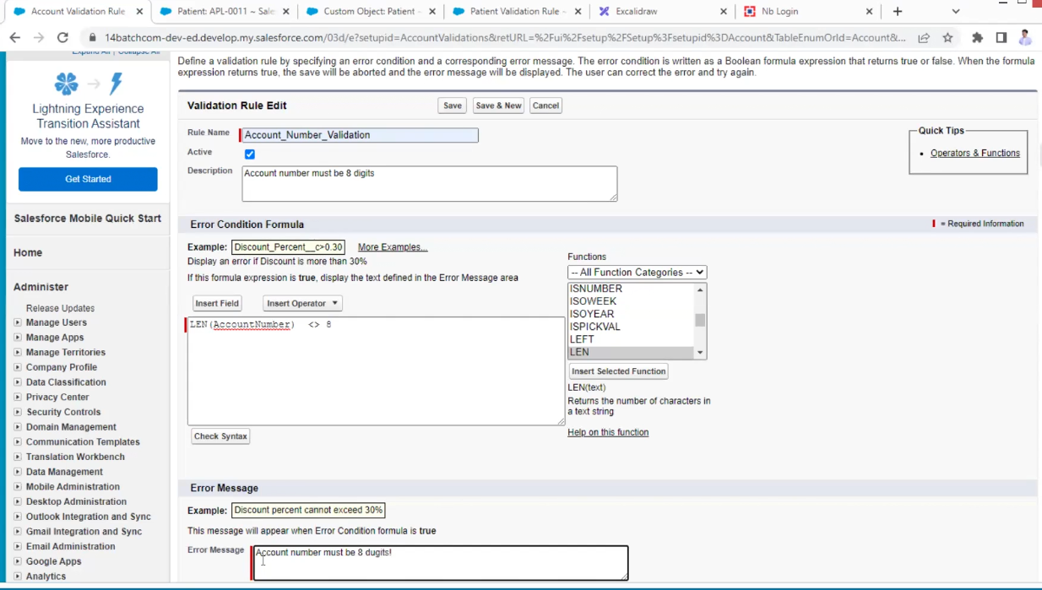

Making records as mandatory

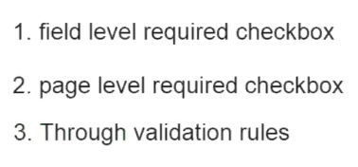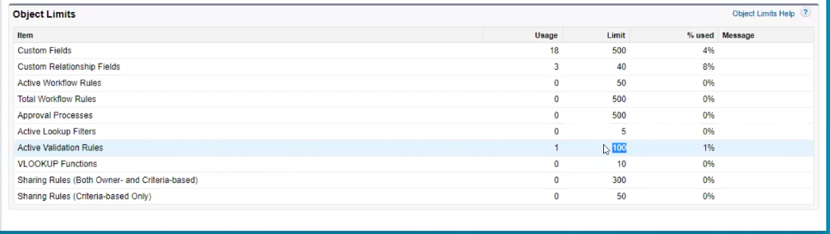

There are some predefined tabs provided by sales force

